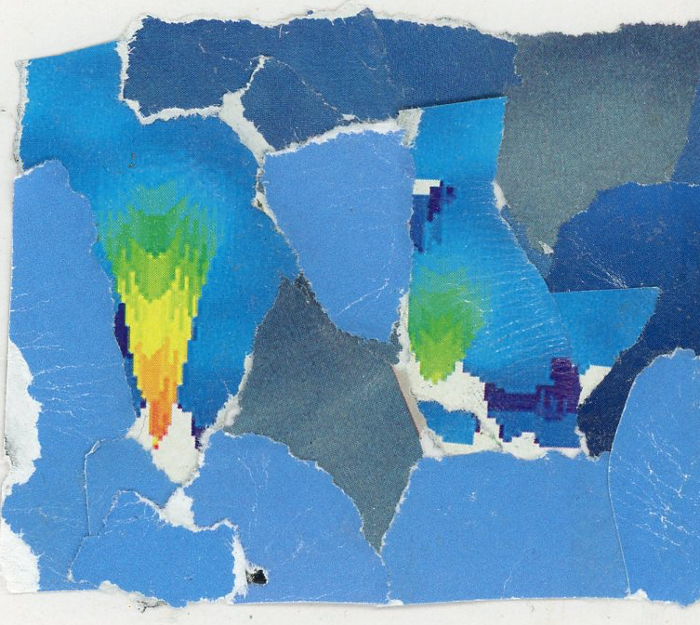
Photography 1
Color Mini Project
Color Relationship Collages

Create 2 Miniature collages (to be mounted next to each other)

CHOOSE A HUE (pulled from the color wheel)
- One collage should be Complimentary (colors directly across from one another on the color wheel)
- One collage should be Analogous (colors directly next to each other on the color wheel)
