Photography 1
Form Mini Project: Paper Sculpture Activity
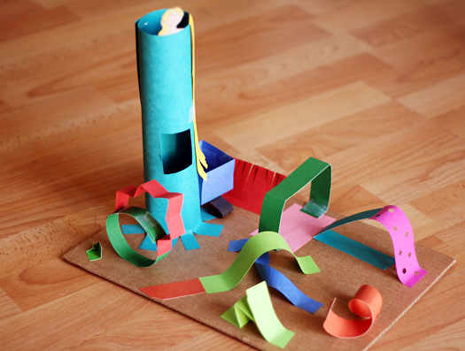
Form is the three dimensional representation of shapes. It can be real (actually taking up three dimensions) or implied (2d made to look 3d). This activity asks you create form in 3 dimensions, then capture it in two dimensions.
- Using scrap paper, glue sticks and tape on an index card, create a 3d paper sculpture using at least 10 paper elements. (BELOW)
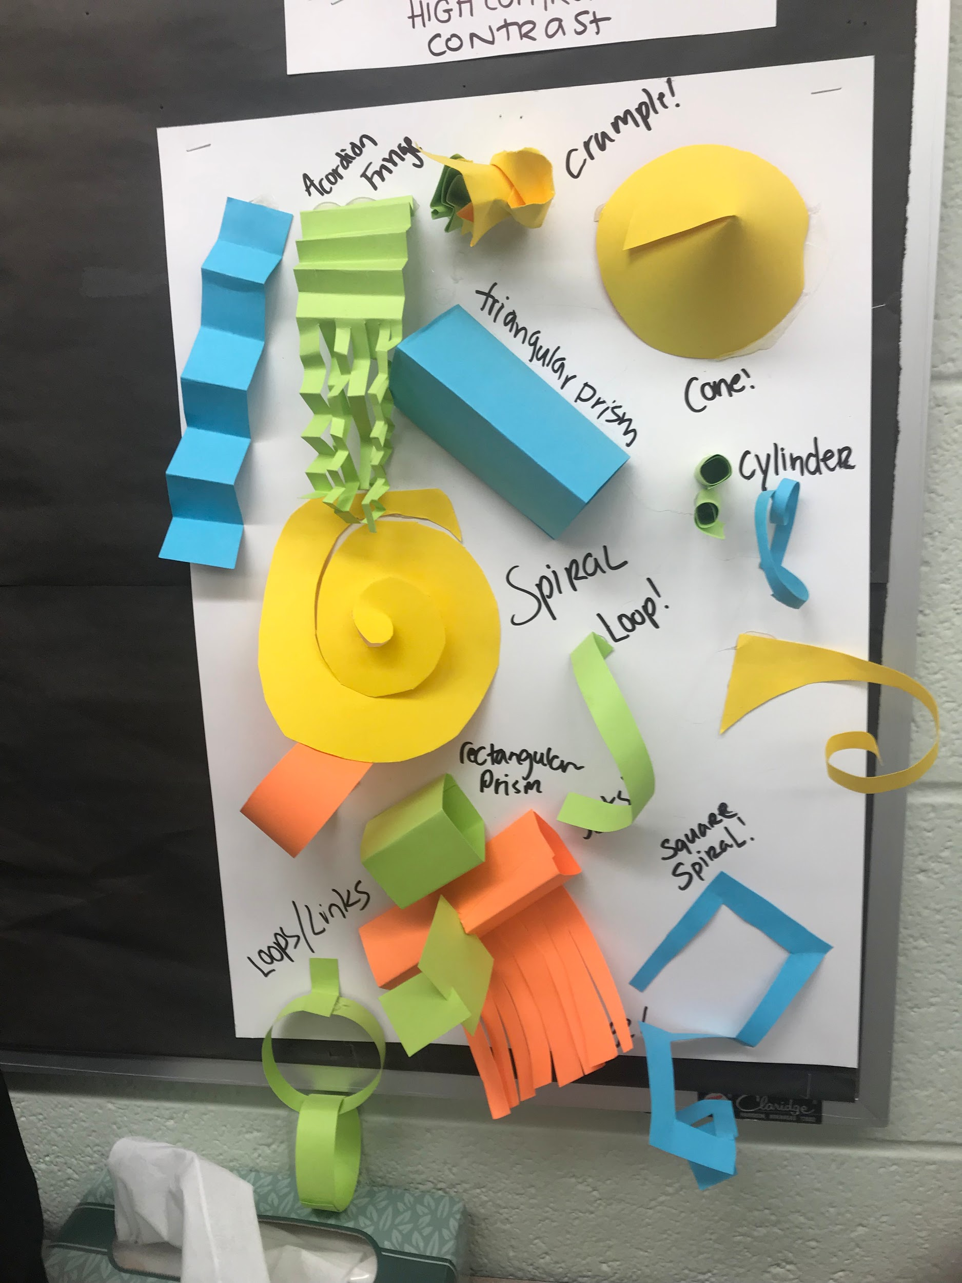
- Take at least 3 pictures of your sculpture that accentuate FORM (hint: remember the slideshow….how can you accentuate form in a 2d photograph?!?).
- Post these photographs on your blog

See examples below:
