Photography 1
Space: Notan Square Activity

Today we learned about space and the multiple ways to create space in a photograph. Your daily project asks you to create a notan square that plays with the boundaries of positive and negative space.

You will need:
8x8 square of white paper
4x4 square of colored paper
A pencil
Exacto Blade
Self Healing Mat
Glue

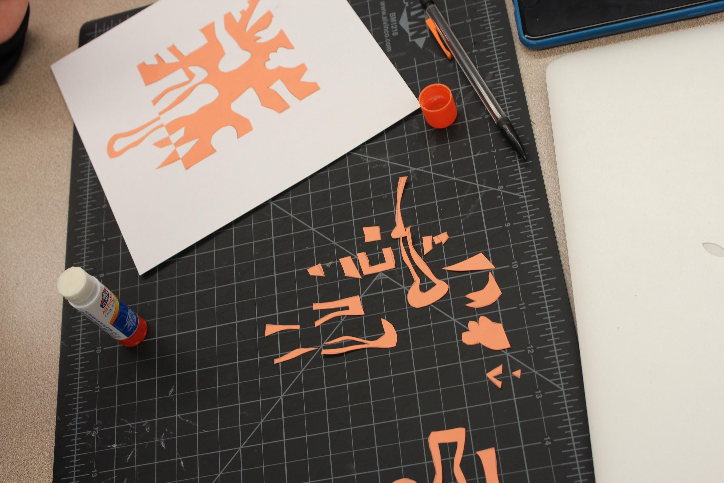
Watch this video (I believe it is easier seen than told…..)

- Begin by drawing on your 4x4 paper, shapes that start and end on the same side (they should not cross the midline of the square). You can mix geometric and organic shapes, there should be several places with layered shapes.
- Cut along each line
- Save all your pieces!
- Glue the remaining negative space in the middle of your white paper.
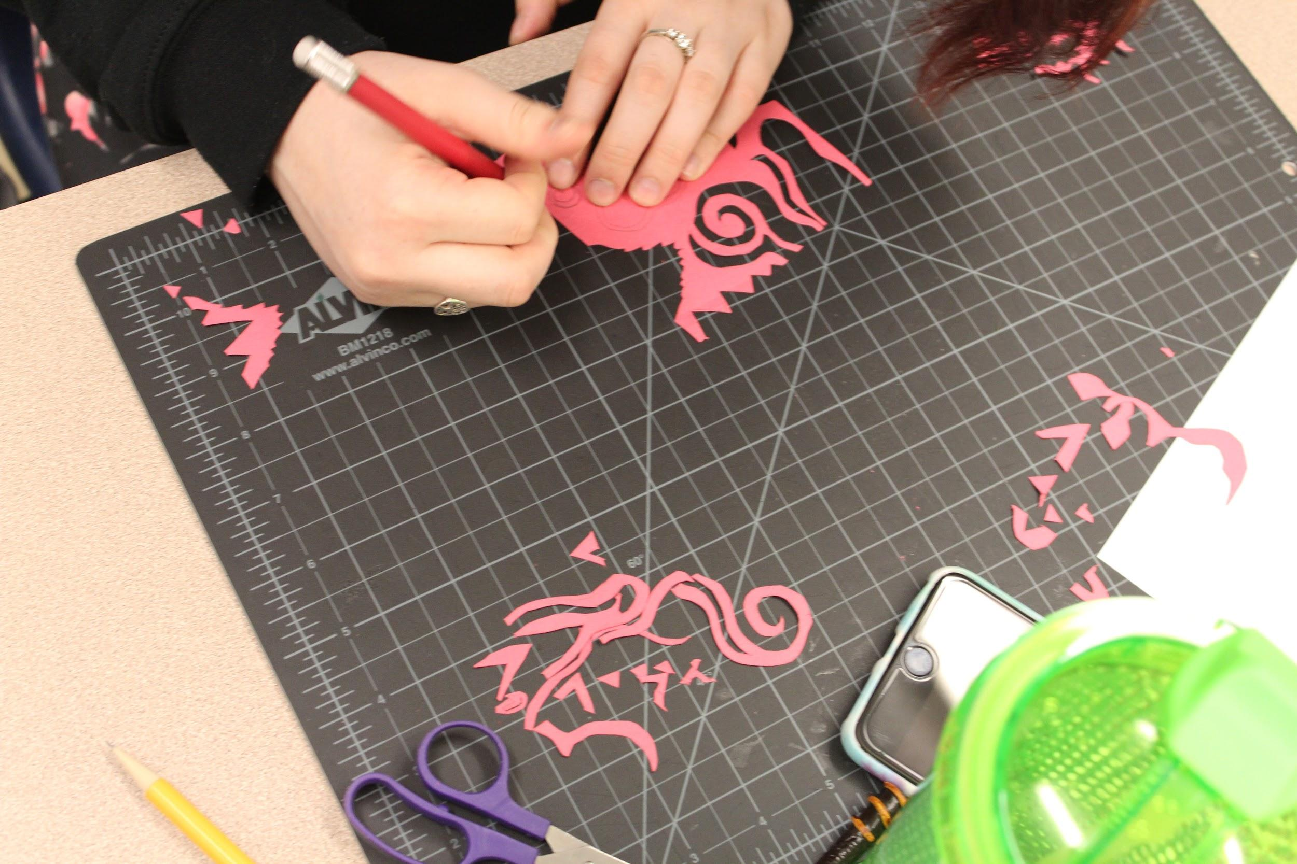
- Reflect each element away from the middle. (hint, there should be a solid line around the edge of the square still…..
- Glue pieces down
See examples below:

